ANT Build for Web project Example

I have taken the example project Sample and the project structure following

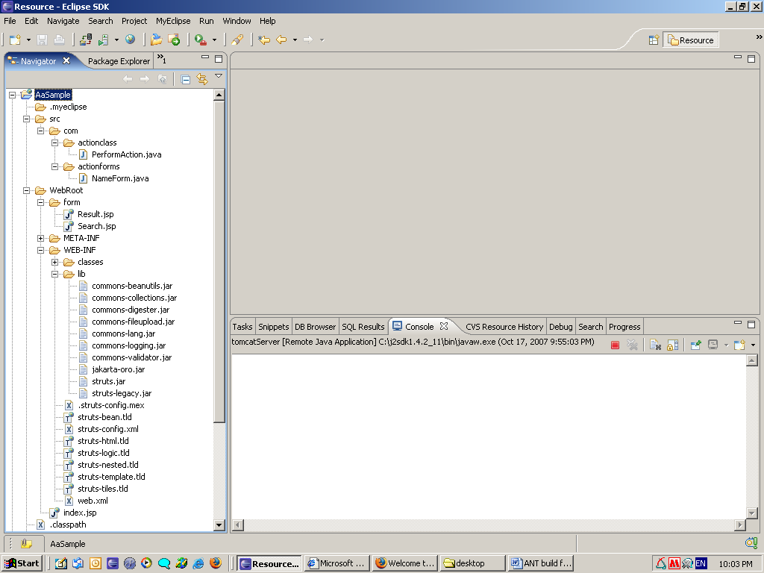

Required jar file for this java project are servlet.jar, struts.jar, commons-beanutils.jar and etc…
Note : if want to run in cmd prompt then download and extract ANT jar file and go with bin directory and paste the build.xml to bin directory and run just like C:\ant\bin\ant

Project Sample

This having following folder like bin, lib, src etc...

form: this is having the jsp (presentation) file and whatever having the project
META-INF: this contain the Manifest file
WEB-INF: this containing the classes file, lib and struts-config.xml, tld file and etc..
src: the source folder contain the java, servlet files

Build.xml:

The build.xml file compiles and run the entire project

<?xml version="1.0" encoding="UTF-8"?>

<project name="webapps" default="all" basedir=".">

<property name="dest.dir" value="D:/Sample1"/>
<property name="war-name" value="${dest.dir}/SampleTest1"/>
<property name="src.dir" value="D:/workspace/Sample"/>
<property name="web-inf" value="${dest.dir}/WEB-INF"/>
<property name="classes" value="${dest.dir}/WEB-INF/classes"/>
<property name="lib" value="${dest.dir}/WEB-INF/lib"/>
<property name="jar-path" value=". /${src.dir}/lib/classes12.jar /${src.dir}/lib/log4j-1.2.14.jar"/>
<property name="servlet-jar-path" value="D:/servlet.jar"/>
<property name="struts-jar-path" value="D:/struts.jar"/>
<path id="classpath" >
<pathelement path="${servlet-jar-path}"/>
<pathelement path="${struts-jar-path}"/>
</path>

<target name="all" depends="clean,init,build,copy,war">
</target>
<!-- Delete the Project structure-->
<target name="clean">
<echo>Cleaning ${dest.dir}</echo>
<delete dir="${dest.dir}"/>
</target>

<!-- Required directory creation-->
<target name="init" depends="clean">
<echo>Creating the required Directories</echo>
<mkdir dir="${classes}"/>
<mkdir dir="${lib}"/>
<mkdir dir="${dest.dir}/form"/>
</target>
<!-- compile the java,servlet etc files) -->
<target name="build" depends="init">
<echo>build/Compile the source files</echo>
<javac srcdir="${src.dir}/src/com" destdir="${classes}" classpathref="classpath"/>
</target>
<!-- copy the all files to destination folders) -->
<target name="copy" depends="build">
<echo>Coping the file </echo>
<copy todir="${dest.dir}/form"><fileset dir="${src.dir}/WebRoot/form"/></copy>
<copy todir="${dest.dir}"><fileset dir="${src.dir}/WebRoot"/></copy>
<copy todir="${lib}/lib"><fileset dir="${src.dir}/WebRoot/WEB- INF/lib"/></copy>
<copy todir="${web-inf}"><fileset dir="${src.dir}/WebRoot/WEB- INF"/></copy>
</target>
<!-- create the war file -->
<target name="war" depends="copy">
<echo>Building the war file</echo>
<war destfile="${war-name}.war" webxml="${dest.dir}/WEB- INF/web.xml">
<fileset dir="${dest.dir}"/>
</war>
</target>
</project>

